Guide to the 3 Urchins: Nat, Squiddly, Jenks
TABLE OF CONTENTS
- Why use the Urchins?
- Intro at The Yawning Portal, Escalating the Troll Encounter, Meeting the Party
- Who are they? Looks, Personalities, Backstories & Roleplaying
- The Ghost Butlers of Trollskull (+ the Haunting of Trollskull Manor)
- How to Spice up the Fireball incident (Mourning Lily)
- Optional Dreamwalk Quest to Save Nat (Inception-Style Side Quest)

APPENDIX A: Narrating the Fireball incident and Dialogue Examples for Volo, Fala etc
APPENDIX B: Nat’s Sign Language Mini-Game (The Charades System)
APPENDIX C: Nat’s Backstory Flashback scene, Hag stealing Nat’s Hearing

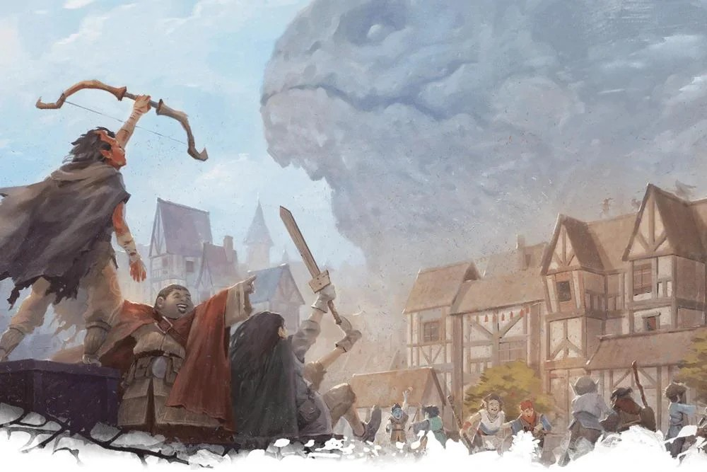1. Who Are the Three Urchins
In the official module, Nat, Squiddly, and Jenks are small NPCs who only appear briefly in the adventure text. They aren’t meant to shape the plot or change the story in a major way. However, the artists for Waterdeep Dragon Heist clearly loved them; they show up in nearly every piece of official art as mere cameos. But they can be so much more!
The Urchins can be introduced as early as the first scene as they watch the band of upcoming adventurers with big eyes. They climb on each other like 3 kobolds in a trenchcoat just trying to get a glimpse of adventure. They might even ask the players’ characters for autographs. PCs tend to fall in love with them instantly. This creates a powerful opportunity for creating stakes later on. These children can become the emotional heart of your entire campaign.
Players might not care about stolen dragons (the coins, mind you) or the political drama of Waterdeep - unless they’re a rogue, rogue’s always care about money - but what about the other PCs with a moral compass? They will absolutely care if a villain hurts these kids, tries to kidnap them, or uses them as leverage.
In fact a Dragon Heist villain who loses the stone of Golorr or its eyes can get right back into the Gran Game by abducting these adorable little orphans at any time. The players might also use them as their own little spies since nobles and other key NPCs may have looser lips around silly little children they would otherwise ignore.
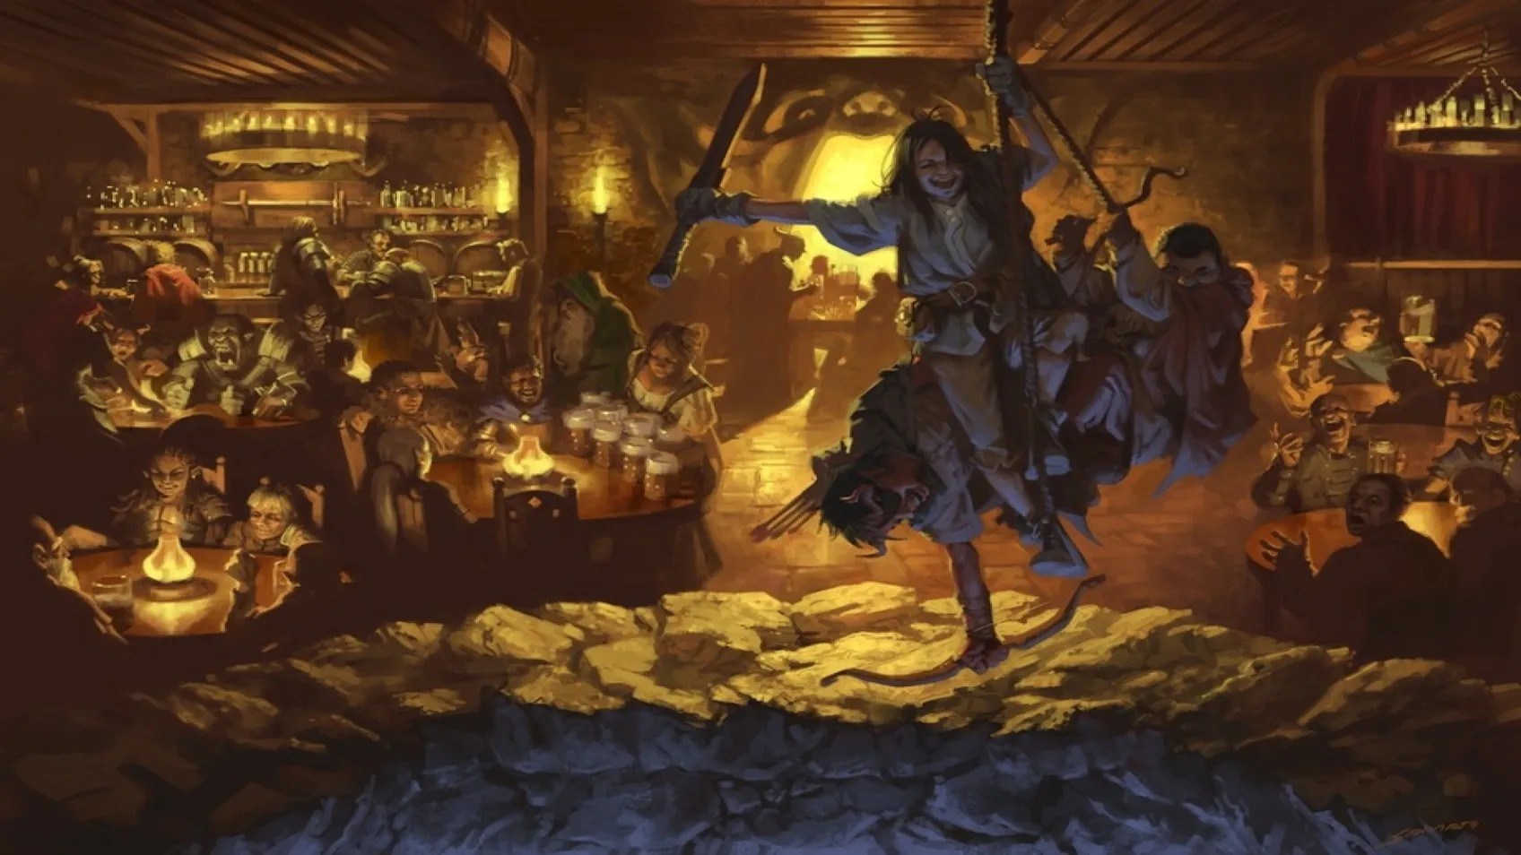
Feel free to be creative with these NPCs and you might even find ways to use their many featured cameos in Waterdeep’s art as evidence that these kids have explored all of Waterdeep and represent the vox populi of the Waterdhavian people themselves.

2. Introductions & The Troll Fight
The Yawing Portal Inn
The 3 Urchins are homeless orphans, but the Yawning Portal Inn is the closest thing they could get to calling home. They may be squatting at the Trollskull Manor, but their sense of belonging and community is tied to the lively staff of the Yawning Portal. Despite the inherent danger of hanging out in the Forgotten Realm’s most famous bars where tavern brawls and dungeon crawls meet, they find it all very exciting.
Durnan, despite his gruff personality and tough exterior, allows them to hang out in his bar and even sometimes allows them to occupy a room on cold nights when business is slow at the inn. It shows he has a soft side and a soft spot for this wild younglings, and Bonnie the Barmaid has tried to find them a good home but the kids are adamant that they are tougher than most of the other kids in the Field Ward, and they’ve got “their own place” (the abandoned Trollskull Manor).
The Troll Encounter
When you introduce the players to the YP, the Urchins can be seen dangling near the well, swinging on the ropes of the crane despite the well-known danger - after all, they are thrill seekers and if it’s not dangerous it’s not “cool”.
When the troll inevitably emerges from the well, one of them (Squiddly in our campaign) starts to panic when the troll climbs out and they miss the ledge when they go to swing across, just barely hanging on to the side of the well, calling for help. This gives the players immediate incentive to help and rescue them.
It also makes the Troll fight more interesting, because a player might not feel confident enough to fight the troll directly but they can’t see idly as a child calls out to them for help. I recommend encouraging one of the players to be seated closer to the well, and wherever they chose to sit is where the Urchin will swing towards and dangle in front of them calling for help.
An Opportunity for Heroism
In our campaign our sailor character Mako showed off his rope skills wrangling the crane, and our Paladin rushed in, vaulted over a table towards Squiddly - failed his check and tumbled forward, landing prone about an arm’s length from Squiddly. I allowed him to “fail forward” and it was a great opportunity to show off the player’s bravery and heroic actions, rather than have them sit out of yet another fight (i.e. if they sat out during Yagra’s brawl).
Meeting the Party and Nicknames
After Volo applauds them for their bravery, the Urchins rush up excitedly to the players, thanking them for saving one of their own and gushing over how cool they were. They ask for their names and request autographs. They also proudly introduce themself as a party of adventurers themselves. Nat uses sign language to introduce herself as the leader (with Squiddly translating), but he interrupts her when she insists their group name is the “Crane Crashers” (as she strikes a crane pose). Jenks chimes in with his own silly name, the Well Wishers (or whatever you want to come up with). Durnan and/or Mirt might laugh, amused, and add in their own nicknames; the Mimicky Mouse Club or the Ragamuffins.
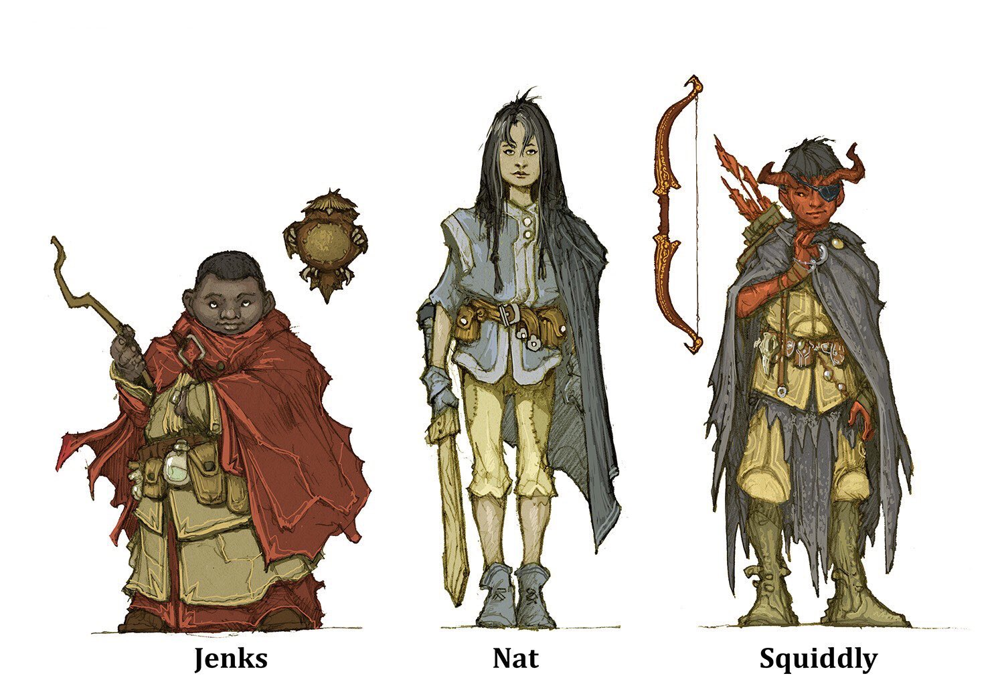
3. Looks, Personality and Backstory

Nat
Nat is a human girl with long straight black hair, age 10-12. She is deaf and communicates through her own handmade sign language. If you have a Drow in your party or want some spice to her backstory, you could say she learned some of her sign language from drow and their sign language. Jarlaxle would be very curious how this clever little girl learned some of his people’s sign language, giving her interesting threads that could connect her to some of the Drow from Skullport.

Backstory and Personality
As the oldest, Nat sees herself as the fearless leader of the group. She is fiercely loyal to her “crew” of Jenks and Squiddly, and is desperate to make herself stronger so she can protect her friends. She often carries a toy wooden sword but her real weapon is her cunning. She is sharp and can learn new skills and adapt quickly to tough new situations, which is something she learned during her time as an orphan in the Field Ward after her parents were killed in an incident involving the green dragon, Claugiliyamatar. This could be as a result of the Dragons roaming around after the events of the Hoard of the Dragon Queen (following the Rise of Tiamat in 1489).
Dagult’s Treachery and Stealing from the Poor
Ancient and powerful dragons like old Claugi were roused from their slumber due to the events of the Cult of Dragon and the Field Ward was desolated by dragonfire, displacing many families, including Nat’s. This was also the year Dagult Neverember was ousted for his corruption after (in my head canon) he was found to be embezzling money from the city that was supposed to be used to rebuild the Field Ward. One of the first things Laeral likely did as the new Open Lord was to ask why the Field Ward’s City Watch was not patrolling that area and why the planned projects for Urban Renewalment and Redevelopment of the Field Ward were so far behind. What she found was that the funds raised for the Field Ward were embezzled by Dagullt, stealing from the poor and setting plans back by years.

Optional Spice
Nat wasn’t always deaf. She had her hearing taken from her by a hag who appeared when she fled from the Green Dragon attack on the field ward (non-canon). This same hag appeared the night of a full moon during Fleetswake Spring Equinox when the barrier between the Fae Realm and Material Plan is thinnest. For more on this event, check out Appendix D and for more on Mother Mirthkettle’s curse on the Trollskull Manor, read my Guide to Lif.
Squiddly
Squiddly is a tiefling boy with bright red skin and small horns that just barely fit under his musketeer’s tricorn hat. He constantly wears a pirate’s eyepatch and enjoys hanging around the dock ward where he can cosplay as a pirate - he even claims he knows how to “Speak Pirate” with cringe-inducing one-liners. The eye patch is purely decorative and it should be obvious to the adventurers it occasionally switches sides from the last time they saw him wear it.
I played Squiddly as an overly confident (at times braggardly) little rascal who is in a hurry to gain respect from the adults around him, and often tries to dabble in grown-up activities. He is often seen asking Bartenders for some of the “good stuff” and being rebuffed for asking for booze. If there was someone in the group who had the skills of a swashbuckling rogue when they grew up, it would be Squiddly. He and Jenks have a bad habit of stealing things, and Squiddly often tries to convince the party to “level with him” and let him participate in their dangerous adventuring activities. He somehow seems to always have a collection of small knives that he forages for in the city, and is actively learning the art of a sneak attack (if only he could remember not to yell Sneak Attack! Out loud as he does so). The party has a great opportunity to teach him some discipline and reward him for following some rules. If they don’t, he will become an agent of chaos which can get the party into trouble.
Optional Spice:
Squiddly is actually the son of a noble family that cast him out due to him being born a tiefling. Several noble families have tried to erase evidence of tieflings being born into their family, such as the Gralhunds.
Alternatively, Squiddly could be a charmed version of Osvaldo Cassalanter, whose memory was wiped after he was charmed by agents of Asmodeus. The Chain Devil the Cassalanters have imprisoned within their attic is actually just a soulless devil Asmodeus put there so no matter what they tried they could never reach him (Detect Thoughts etc), Goggles of Mind reading etc.
Squiddly doesn't seem to remember his past whenever it is brought up by the party or Nat and Jenks. Whenever he tries to think about his parents his brain goes all fuzzy. This is due to the special memory charm cast on him by devils of the Nine Hells, and it might be up to the players to save Squiddly from the same fate as the other Cassalanter twins when their ninth birthday arrives.
This option might be preferable if you want to give the players a way to feel good about saving the Cassalanter’s children. You may have to edit out the part of the contract where they need 99 Souls in addition to the money owed so that there is a way to save Squiddly without sacrificing innocent lives.

Jenks
Jenks is a chubby human boy with dark skin and a soft voice. He carries a toy wand and a pet owlbear that he believes serves as a good luck charm to protect him (in Nat’s Dream world, this plushie actually becomes a real owlbear).
In our campaign Jenks was the one who was not caught by the Fireball at the beginning of Chapter 3. This awakened a passion within him to be bold and try to help the party track down whomever hurt his friends in the fireball incident. Even if the party tells Jenks to stay behind, he will fight them on and sneak behind them. He joined our party during the quest and often served as a peanut gallery whenever crazy stuff happened.
One of our party members bought Jenks a “training wand” from Fala, where it can cast prestidigitation and on a DC 14 Arcana check can cast fire bolt. Jenks is emboldened by this and naturally gravitates towards the spellcasters of the group trying to learn more spells. Prestidigitation is obviously quite the useful cantrip and he uses it to snuff out candles and other light sources when sneaking.
Optional Spice:
Jenks is actually his last name. His first name? Leeeeeeeeeroy Jenks! He’ll have his moment in the spotlight one day. Perhaps when the players are too hesitant to act, he will charge in dramatically and force them to put their plan into motion, Leroy Jenkins style.

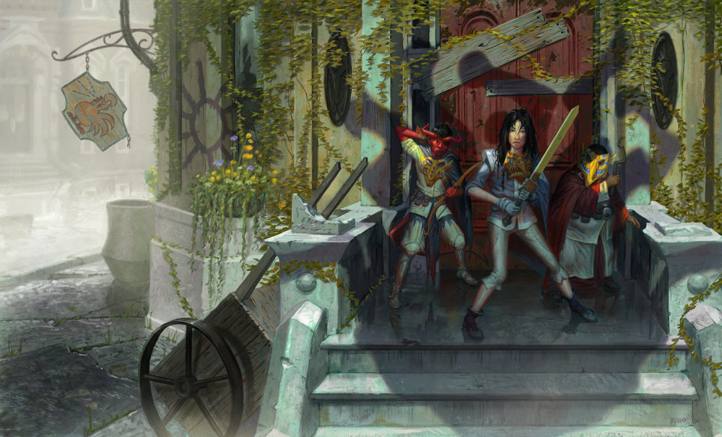

4. Ghost Butlers!👻Urchins in the Trollskull
When the players arrive at Trollskull, they will likely be aware of the rumors that Trollskull Manor is haunted, but it could just be that there are some orphans in their playing pranks on people to keep them out. In horror movies, they often get people to drop their guard before scaring them. The orphans can get your players to think the rumors may have been unfounded, and that Volo was an idiot and allowed himself to abandon the house he bought (to write Volo’s Guide to Spirits and Spectres) because of these kiddos.
However, the Trollskull really is haunted! For details on the hag who used to run an orphanage and how to use Lif (the ghost haunting Trollskull to protect outsiders from the Hag’s curse) check out my Guide to Lif and the Haunting of Trollskull Manor.

Home Alone
As the players explore the Trollskull Manor, they encounter childish traps. The door around the back leading to the 2nd floor has grease on it. Opening the doors triggers pots, pans, cans, and other heavy objects that swing down for bludgeoning damage. If they enter through the first floor they see there used to be a staircase leading to the 2nd floor, but it had been removed to prevent patrons from the bar from accessing the 2nd floor. A hole in the ceiling near the kitchen has a rope dangling from it, but if a player tries to climb it the rope is cut. Feel free to add in other childish traps but also mix in ambiguous sounds of thumping and/or scurrying about from the kids that might be interpreted as ghost noises.

Mixed messages + 3 Layers of Hauntings

As the players progress throughout the Trollskull (2nd and 3rd floors) they encounter more of the actual ghost, Lif, and his real haunting. These mixed messages can really keep the players on their toes. And of course, the third and final layer to the haunting is the actual threat, the curse emanating from the cellar which used to be the Hag’s chamber where she performing her twisted rituals (again, see the guide for more info on Mother Mirthkettle and the cursed cellar doll encounter).

Sneak Attack!
Feel free to introduce the orphans however you see fit, but I personally had them appear once the players reached the 3rd level of the Trollskull, after they had a taste of Lif the Ghost in the Hallway (in the mirror) trying to create the frightened condition upon the players to run away.
The Urchins defend their home with Nat and Squiddly flanking the players at the top of the stairs as Squiddly or Jenks yells “SNEAK ATTACK!” as their swords/bows bounce harmlessly off the players.
Ghost Butlers!
As the players build rapport with the Lif and begin to use him as a servant and/or bartender, the Urchins also want to help make Trollskull come to life once again and make Lif happy. They volunteer to earn their keep and help serve Lif as his team of Ghost Butlers. They announce that they are his Ghost Butlers and even come up with quite the catchy theme song to go along with it (We ain’t afraid of no ghosts!).
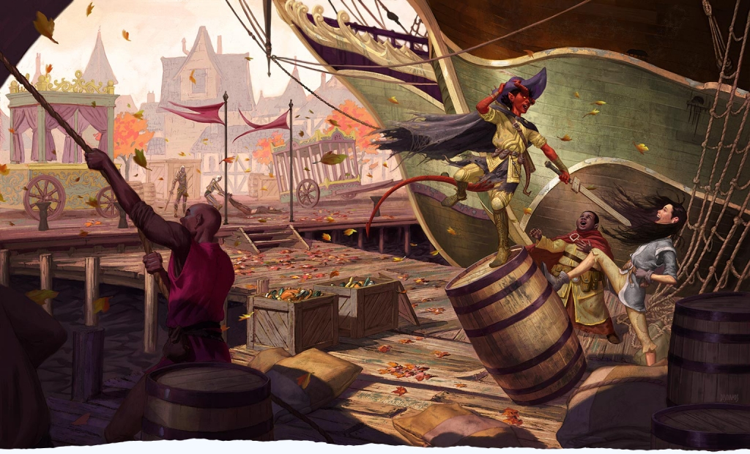

5. How to Spice up the Fireball (Mourning Lily)

Turn the Fireball Into a Personal Tragedy
In Justin Alexander’s Alexandrian Remix he suggests making the Fireball incident that kicks off Chapter 3 in a personal way by having one of the Orphans caught in the explosion. This is an excellent idea to make the players care about investigating the explosion, and we will be building upon this idea.
We are also going to be adding some other notable NPCs, namely Fala the herbalist and potion master who works at Corellon’s Crown and everyone’s favorite chronicler with a heart of a gold and a thorn in your behind, Volothamp Geddarm. We are also going to have Nat and Squiddly caught in the explosion for maximum effect. But first, what were they doing outside of the Trollskull on the morning of the explosion anyways?
The Morning of the Explosion, Nat is missing
The players have just fixed up the Trollskull Manor and are almost ready to open their new cash cow. They are excited but they are also a bit concerned because Nat has gone missing. As a token of her appreciation for taking them under their wings, Nat wants to get a rare flower that only grows in a hard to reach place (i.e. somewhere like the Hanging Gardens on the God Catcher). She never returned and Squiddly has gone looking for her. After helping her sneak into the hard-to-reach location and acquire, they head back to the Trollskull, only to get caught in the edge of a powerful Fireball cast by the Nimblewright on Urstul Floxin and Dalakhar.
Volo’s Lockhart Moment
The crux of the Fireball incident is the players wake up to the explosion and find Nat and Squiddly unconscious, and this is where Volo in his misguided helpfulness will make things both better and worse for Nat.
When the explosion goes off Nat is saved from all but the concussive force from the fireball explosion’s splash damage as Squiddly heroically pushes her out of range of the explosion. Lucky for him he is a tiefling with fire resistance, and he managed to shield her from the burn damage but both are unconscious and badly hurt.
Enter Volo, who was just in the midst of an argument he was having with the paperboy on how to properly market his latest article published in the Waterdeep Wazoo. As the party arrives on the scene of the explosion Volo emerges amongst the chaos, explaining he saw the whole thing and attempts to heal Nat with healing word, but since the spell has verbal components, and Nat cannot hear, it stabilizes her body without restoring her mind. For fans of Harry Potter, this is similar to when Harry is healed by the inexperienced Gilderoy Lockhart and must go through a much longer healing process as a result. Volo does mean well but he’s no magical medic, and now Nat will not regain consciousness no matter what spells are cast on her, and healing potions only heal her outwardly.
The Mourning Lily and Fala’s Nature Check
Clutched in Nat’s scorched hand, the players find a special magical flower that she had just picked this morning. Fala runs out from the Correllon’s Crown after witnessing everything and lends their expert opinion on the flower, saying it likely saved her life. Nat may have mistaken the flower’s name for the “Morning Lily” because it only blooms in the morning on spring days, but it is more properly referred to as the “Mourning Lily” because it contains magic used to preserve life by binding the soul to the body. It is sometimes used in seance-like rituals as a component for contacting loved ones whose spirits linger. Now it has attached her soul to her body but her mind is in a comatose state.
Beauty and the Priest
With each day that passes roll 1d4-1 to determine how many flower petals will fall from the Mourning Lily flower (usually with 6 leaves, but you can adjust as needed). When the final petal falls, the power of the flower will fade and Nat’s soul will no longer be linked to this world. This ticking clock mechanism puts the pressure on the players to save her and also contact some of the city’s best healers and/or knowledgeable mages.

Circle Cast! Inception Ritual
This need for a magical consultant and/or healer creates an opportunity for your players to talk with wizards like Gale of Waterdeep (see my Guide to Gale) - who is also going to be salivating over the opportunity to see the stone of Golorr, and the Blackstaff herself Vajra Safahr, or even a cleric from the Temple of Lathandar. Gathering at least 2 casters and possibly even combining them with a caster in your party will allow you to Circle Cast a powerful spell that allows you to enter Nat’s dream world and rescue her. Powerful mages are recommended since they would know high level spells such as dream and demiplane.
This creates a portal that players can enter. You could let it end right there as they do some skill checks to convince Nat to come back. Or…you can make a little side quest out of it where the players enter her dream space and fight the monsters in her head.
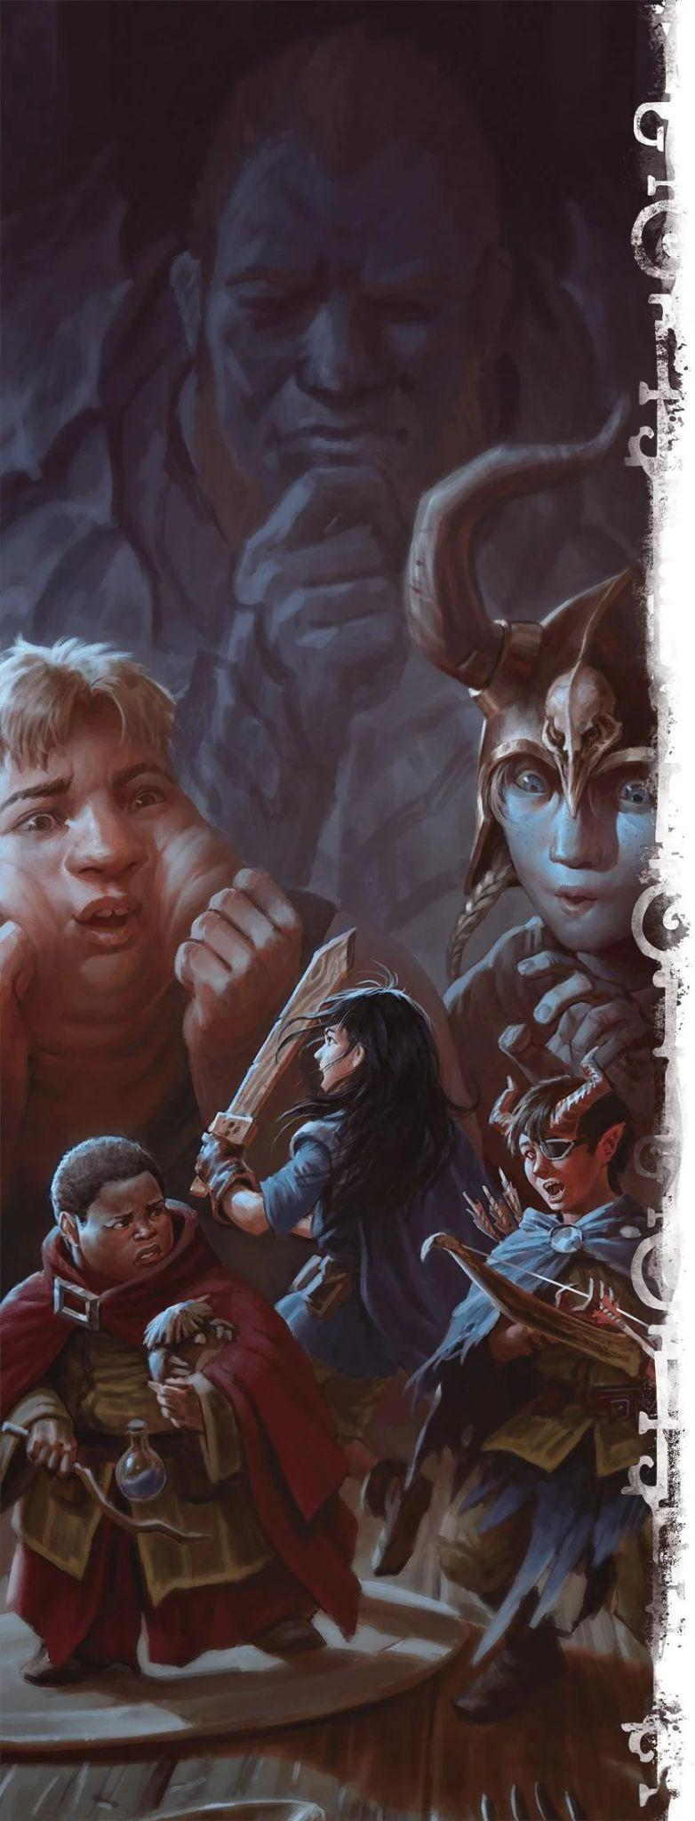

6. Dreamscape Side Quest to Save Nat
Once the Circle Cast ritual opens a portal into Nat’s mind, the players are transferred to a dream world where the laws of physics, magics, and even game mechanics may vary. This can not only be a cool quest to throw interesting new creatures at your players, but it is also a great way to test out some fun new ideas you’ve been wanting to test out and try something different than your normal combat and/or exploration.
Layout of the Dream World
You can have the players explore one single area or you can use multiple locations. I will outline 3 different layers that can be used, but feel free to chop it down to just a single layer for time reasons. Think of it as an Inception-like quest where the deeper you go the more dangerous things get and the different levels you delve represent her surface thoughts but progress to her inner fears and struggles as you go down each level. The goal is to help her face her fear(s), restore her hope, and bring her spirit home.
Each layer represents the 3 pillars of D&D, Exploration, Combat and Social Encounters:
Layer 1: Waterdeep from a Child’s Perspective (Exploration)
Layer 2: A Ethereal and colorful dreamscape (Combat)
Layer 3: A Castle guarding Nat’s mind from intruders (Social)
Side Note: If you want you can have the side quest take place in the Astral Plane, or you can describe it as a Plane of existence similar to the Astral Plane to avoid any fears of people nitpicking lore and “um acktually-ing” worldbuilding, them on the lookout for githyanki, etc.
If you do describe it as the Astral Plane, check this passage out I got from an old D&D sourcebook:
Traveling through the Astral Plane by means of the astral projection spell involves projecting one's consciousness there, usually in search of a gateway to an Outer Plane to visit. Since the Outer Planes are as much spiritual states of being as they are physical places, this allows a character to manifest in an Outer Plane as if he or she had physically traveled there, but as if in a dream.
A character's death-either in the Astral Plane or on the destination plane-causes no actual harm. Only the severing of a character's silver cord while on the Astral Plane (or the death of his or her helpless physical body on the Material Plane) can result in the character's true death.
Circle Casting Cinematic (Box Text, Read to Players)
A soft light swells around you as the ritual circle ignites. Colors melt, swirl, and then stretch like wet paint. The world rushes upward and downward at the same time. You feel weightless, as if someone gently lifted you by the shoulders and swaddles you softly as you float to the ground.
When the light fades, you stand in Waterdeep’s Field Ward. At least, it looks like the Field Ward. Everything is far too large. The small buildings tower over you. But one thing has not changed: the smell. The Field Ward is not an official Ward and signs of its lack of sanitation and proper sewer drainage are readily apparent to your noses.The ward had muddy, unpaved streets. The houses are crowded together, the streerts are narrow and noisy with the din the uneasy rabblement around you, the foul-smelling with the stench of slaughter-houses, tanneries, and waste.
Every person who walks by is a plush, puppet-like version of themselves. Their limbs bounce. Their heads wobble. Their smiles are made of thread. Even your own hands look stuffed with cotton, and your weapons have transformed into toy versions of themselves.
Somewhere deeper in the city, a far off voice calls out in fragments. Thoughts, not words.
Layer 1: Waterdeep Distorted
Players find themselves magically whisked away to the Field Ward, where Nat was raised by her parents until their untimely deaths. The players walk through this destitute shantytown and witness an area of the city that is in even worse shape than the Dock Wards. Further description of the Field Ward can be found below, but the first thing the players notice is that everything seems strangely distorted. They have all been shrunk to 3 feet tall and everyone and everything around them seems larger as if viewed from a small child’s perspective.
Optional Spice: Everyone in Waterdeep has been turned into muppets! And conversely when you find Jenks (see Frozen Fireball section) his Owlbear plushie has turned into a real Owlbear.
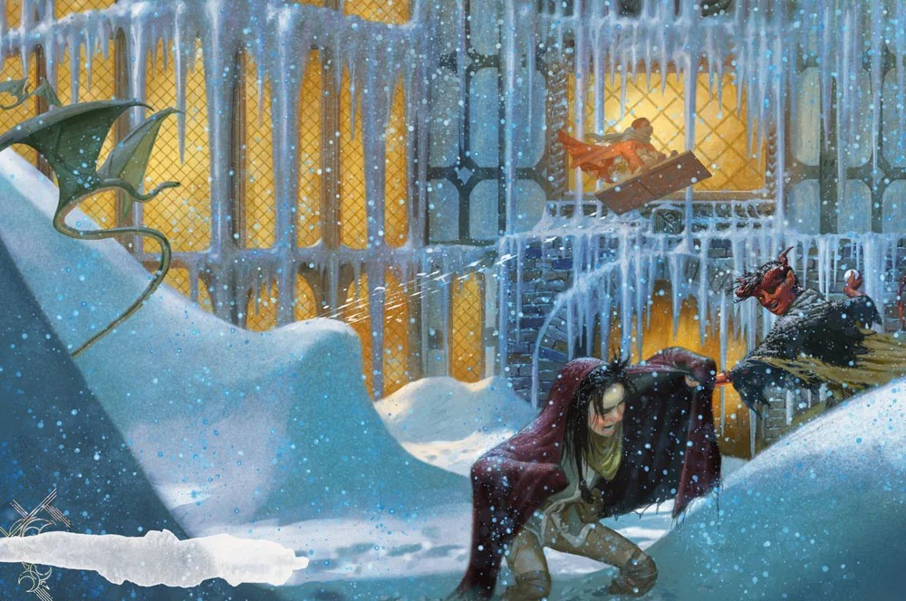
Describing the Field Ward
The Field Ward feels out of place compared to the rest of Waterdeep. Originally it was where caravans parked outside of the city during the Troll Wars and eventually these small camps formed muddy unpaved roads and small hovels and shacks were erected. Remind the players that the Dock Wards they visited Finding Floon may have been poor, but at least they were a hub of activity for the Harbor’s trade and festivals. The Field Ward lacks any real significant businesses and there’s hardly even proper taverns, except for the Endshift Tavern where they can see some gruff looking city guards getting sloshed off duty. If a resident is lucky one of these guards might be able to help if a scuffle arises, but the odds are slim and most guards give firm reminders of what “off duty” really means; they’re on their own.
Finding Where Nat is Hiding
The PCs will travel south to try to find where Nat might be hiding. Their first thought might be to go the Trollskull, but if they don’t they’ll have to pass through the Sea Ward where they will likely get chased off by scary Monster-sized caricatures of the City Watch (i.e. Bugbears or whatever Monster stat block you see fit) who accuses them of being up to no good and bothering the rich folk with their begging (roll skill checks as needed or suggest some fun ones on our community Discord. For now let's railroad the players back to the Trollskull).
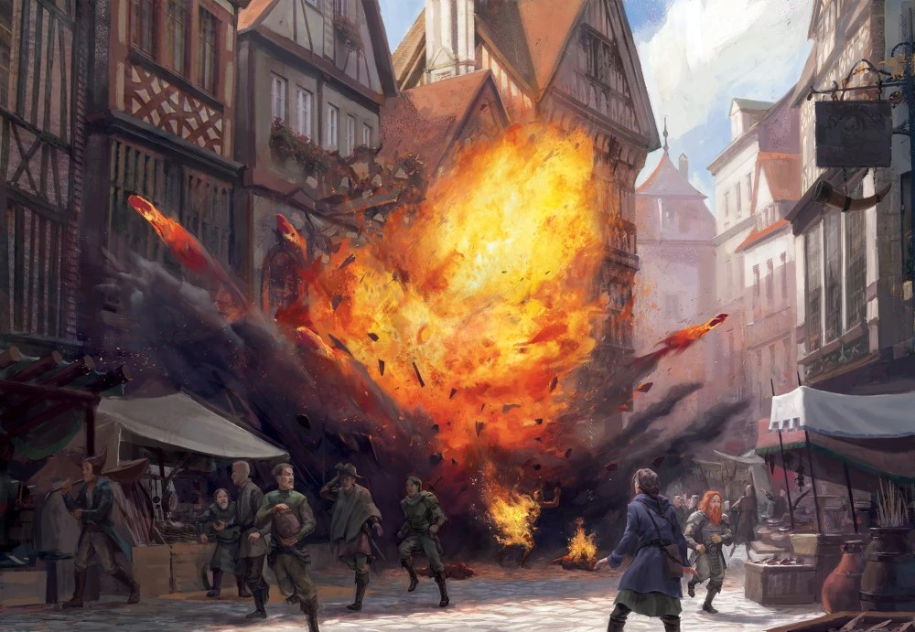
A Light in the Distance, A Moment Frozen in Time
If the PCs roll a good insight or Perception check, steer them away from the Sea Ward and towards a phosphorescent glow emanating from the direction of Trollskull Alley.
Trollskull manor looks fantastic, like a palace, as a symbol of the way Nat's perceives her new home. When they arrive, there's a fireball explosion frozen in time. There you find the urchins frozen in time as well, but they look more…grown up, in a way. They look like proper adventurers and they may even have some of the traits your own PCs have. Maybe Jenks' spellbook looks the same as your wizard PC, or Squiddly is wearing daggers the same way your rogue PC does. Nat however, is not there. Only a trail of flower pedals. Players can use a DC 10 Survival check to follow the trail or DC 13 Persuasion can speak with heroic Squiddly and Jenks (who sound older but speak the way a kid would try when trying to sound older, with their same childlike speech patterns. They are children roleplaying as adults).
Before the players depart, Jenks rushes after them and tells them “Don’t forget THIS! He’ll keep you safe!” as he tosses them his plushie Owlbear. The Owlbear (and all children’s toys) in this world transforms into a real Owlbear, and the players can also follow (Athletics 10) and/or Mount (Animal Handling 13) the Owlbear as it tries to follow Nat’s scent or the flower petals.
Garden of the God Catcher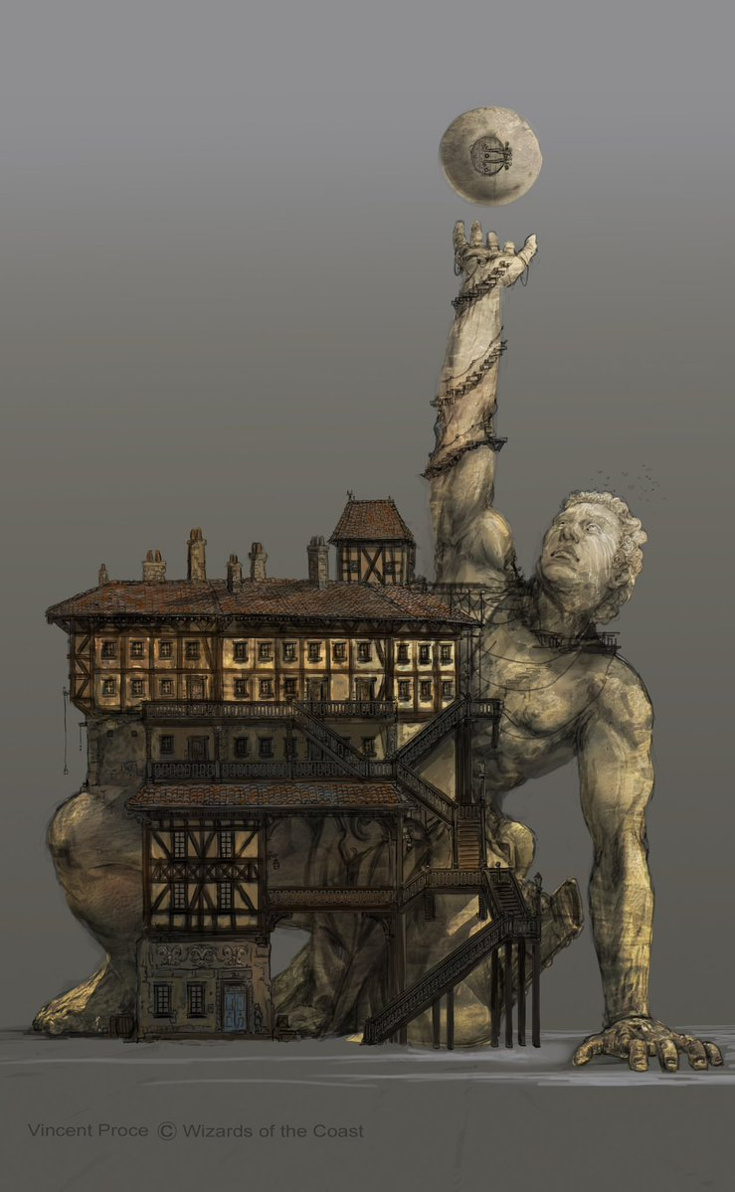
The trail leads the party deep into the Caste Ward where they must climb (or er, just walk if the concept art is to be believed) to the top of the God Catcher’s outstretched arm.
Note: If you do want to soften up the player’s HP a bit before the next Layer (the combat level) feel free to add some obstacles getting up to the top of the statue’s arm and/or skill checks for stealth, acrobatics, persuasion etc to get past the people who work at the God Catcher or any of Nat’s nemeses who are guarding it. For example, it could be guarded by shadow versions of teenage bullies throwing giant pebbles, or mean people from the Field Ward throwing things, or Nobles staring at them with psychic damage glares).
In my guide to Gale I suggested that the God Catcher once fought the Lady Dreaming Statue in fierce battle piloted by Helm and Mystra, and that in the end Helm was victorious and managed to catch a God (Mystra) and held her power for all to see. I have seen (and own) various modules on DMsGuild that suggest what might be built along and atop of the God Catcher, but for our purposes we merely need to know that there are hanging gardens that surround the perimeter of the floating orb.
This is where Nat snuck up and picked the Mourning Lily from its garden, a lily that is said to only bloom at the morning’s first light. And this is where Nat is hiding
Describing the God Catcher and the Garden
Note: If you plan to use the Concept Art above, you might want to forgo the floating cobblestone and have them navigate through the God Catcher’s building and spiral staircase made from wood instead.
Read Aloud:
“Ahead, the mist lifts, revealing a colossal shape that dominates the skyline. It is the God Catcher, the titanic stone statue frozen in the act of rising from the earth. In the waking world it is massive. Here, in Nat’s dream, it is nearly divine. The statue reaches so high that its fingers brush the sky, and tiny stars cling to its surface like morning dew.
A staircase of floating cobblestones rises toward the statue’s outstretched hand. Each stone bobs gently, as if suspended by a child’s imagination. As you ascend, plush birds swoop past your heads, their felt wings flapping silently.
At the top, cradled in the statue’s palm, is a small garden. Soil glows with soft blue light. Vines curl in spirals like doodles drawn by a child. Flowers bloom in impossible colors. Some shimmer with sunrise pink. Others drip silver starlight. And at the center grows a single patch of delicate, glowing lilies.”
Down the Rabbit Hole - the God’s Orb
The players can do an Investigation check or Perception check to hear the sounds of a little girl weeping from inside the orb. Upon entering the Orb, the players sink down into the next level of the dream into an ethereal realm detached from the rest of the world. (Optionally, you can also have the Orb’s spiral staircase extend to a celestial staircase if you want to go up into the clouds instead of down).

Layer 2: The Guarded Ethereal Plane

The first level was all about exploration, but this layer is all about combat, so we simply need a dreamy looking location and that comes down to your personal preference on aesthetics and whatever vibe you want to create for the dream monsters to emerge from. Ideally it has some sort of location to infiltrate like a Castle or stronghold of some sort for the 3rd layer’s sanctum of silence to be housed, but hey this is a dream world, her sanctum could pop up anywhere.
For this location, I recommend one of the excellent dream maps from Czepeku or DWW below.
- Candy Castle Map (day or night, but they night version’s pretty sweet)
- A Rose-Hydra crypt (Hydras make excellent mini-bosses and it matches the theme of the Mourning Lily protecting her soul and therefore needs to be conquered).
- This Astral-plane esque Mega-Map (you can get the whole map or sections of it that fit together for a partial smaller map) with lots of platforms to jump
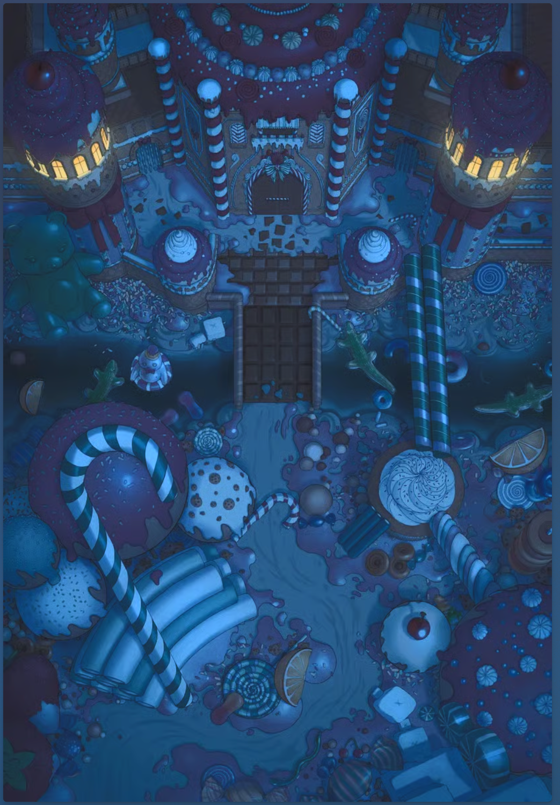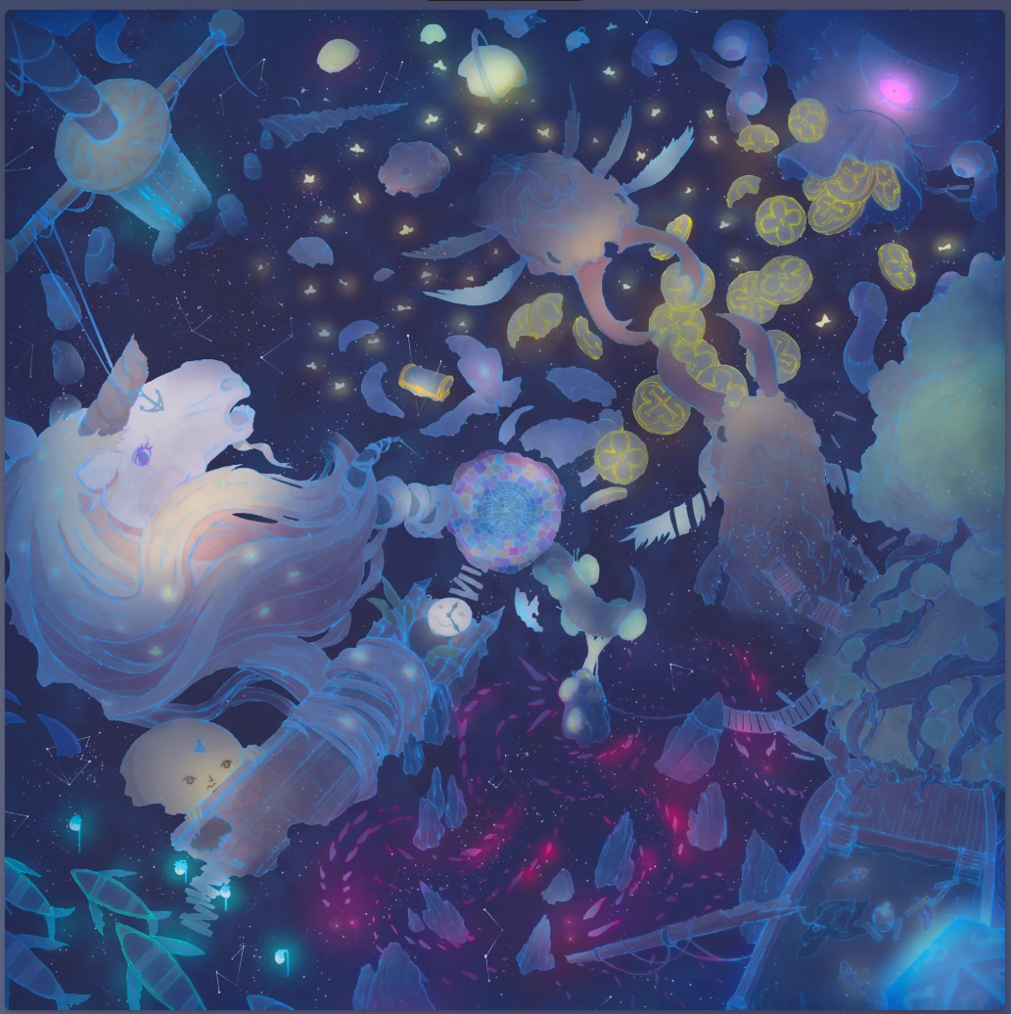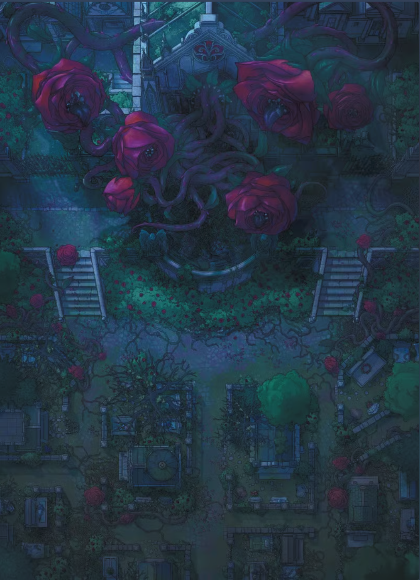
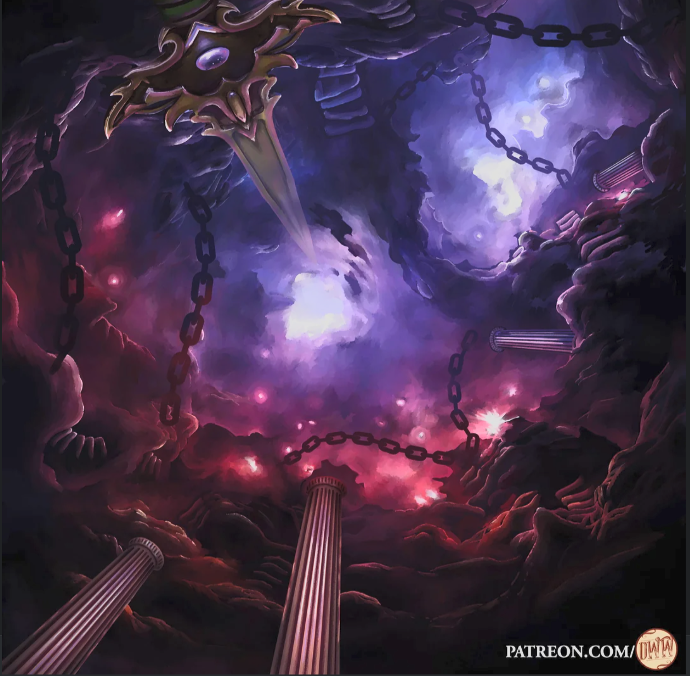
I am also a big fan of Domille’s Wondrous Works so I would be remiss not including one of her maps, which could serve as another location in the dream world for when you need a darker and less whimsical take on a dreamscape (nightmare-scape). Which you can find on their Patreon here. There is a free version of this available as well, unlike the Czepeku maps (although honestly most of their maps can be downloaded for like $1.00).

Regardless of what monsters your PCs face, they will advance towards their final objective, a place on the map where they can sense Nat’s presence calling out to them, her innermost Sanctum: The Sanctum of Silence.

Monster Ideas (Work In Progress):
- Nat’s fears manifest as dementor like creatures this level. When players take psychic damage, they must briefly narrate a memory or emotion that strengthens their resolve (WIS Save 10-15 depending on level of effort roleplaying) or the fear grows stronger and the next fear attack gets an extra damage die rolled for Psychic damage
- Nightmare Haunt
- Wraiths (basically Dementors) + maybe a specter minion or two
- Ghosts (For Possession only, to force a little PvP combat)
- Bullies that are Gibbering Mouthers
- Banshee (i.e. Nat's Mom haunting her from the grave)
  - Deathly Wail does Psychic Damage or makes them drop to 0 HP if lower than 25 HP
Unique Mechanics to try for the combat in this area:
- It’s a Bonk Fest! The Players Weapons have been turned into Toy Versions, none of their Magic Items work. Everything is bludgeoning
  - Paladins: Wooden Sword and Shield; The Barbarian has a giant Squishy Hammer and two rattles (handaxes)
  - Spells turn into looney tune versions and/or wild magic surge with every casting
  - All damage from attack rolls becomes bludgeoning and let the bonk fest begin
- Everything hits! To speed things up, just roll damage die
  - Everything hits like in Nimble 2.0, you just roll damage die when you attack. If it is a 1 on the die, you miss, otherwise you hit with that damage rolled.
    - If you roll more than 1 die, the leftmost die is the one that determines if you Crit Fail or Crit Hit
    - If you Crit (roll the max on the Primary (leftmost) die, it explodes - meaning you re-roll it and add that damage. It can explode as many times as luck provides
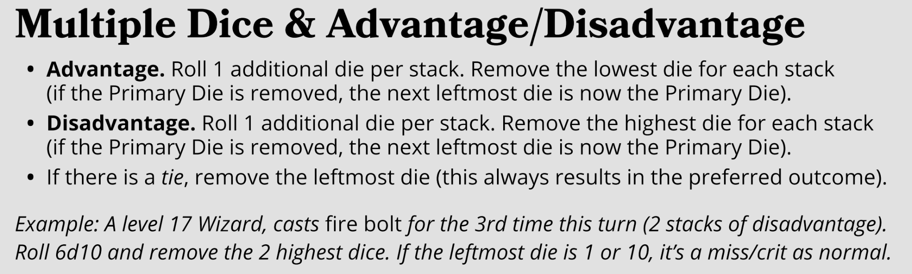
  - Rolling with advantage? Roll an extra die and remove the highest or lowest result, or check this handy image from Nimble’s DM cheat sheet:
- Silence Zones
  - Certain areas completely remove sound. Spells with verbal components fail. Players must communicate through gestures similar to Nat’s sign language. Give advantage to players who roleplay signing.
- Emotional Shields
  - Positive emotions create temporary protective barriers. Comforting words, encouraging gestures, or recalling happy memories give temporary hit points or advantage on saving throws.
  - You can also apply something like an emanation similar to a Paladin’s Aura if your character roleplays calling out to Nat (words of encouragement, praise for her, sharing a happy memory they had, making her a promise for when they get back home, etc)
    - Aura of Courage: you and friendly creatures within 10 feet of you can't be frightened while you are conscious.
    - Aura of Protection: Bonus to saving throws
      - “Whenever you or a friendly creature within 10 feet of you must make a saving throw, the creature gains a bonus to the saving throw equal to your Charisma modifier (with a minimum bonus of +1). You must be conscious to grant this bonus.”
    - Aura of the Guardian: Reaction to tank damage from allies
      - “When a creature within 10 feet of you takes damage, you can use your reaction to magically take that damage, instead of that creature taking it. This feature doesn't transfer any other effects that might accompany the damage, and this damage can't be reduced in any way.”
    - Aura of Warding
      - “Ancient magic lies so heavily upon you that it forms an eldritch ward. You and friendly creatures within 10 feet of you have resistance to damage from spells”
    - Aura of the Sentinel
      - “you emit an aura of alertness while you aren't incapacitated. When you and any creatures of your choice within 10 feet of you roll initiative, you all gain a bonus to initiative equal to your proficiency bonus”
- Emotional Damage
  - Everyone has access to vicious mockery and cutting words when facing the bullies and/or guards that Nat faces in the first section of Waterdeep (you can make this apply to any enemy but these seem the most apropos).
- Charades-Based Initiative
  - Before the first round, each player must perform a gesture to represent how they enter combat. Nat interprets it and assigns them an initiative bonus or penalty. It’s her dream and she has some control over the way the fight flows. She may even occasionally intervene in magical ways without her being physically present.
- Floaty Moon Jumps!
  - Jumping causes characters to bounce unnaturally high. Use this to reach rooftops or platforms.
- Gravity Changes Direction
  - Characters can choose a direction to “fall” in. Falling grants fast (+10 ft) movement. Landing requires an acrobatics check or they slide 1d4 extra spaces past their intended square.

Layer 3: The Sanctum of Silence (Working on cleaning this last part up atm)
Ever seen the movie A Quiet Place?
There are those monsters in this Sanctum, minions bearing the mark of an evil Hag (see Appendix for Hag flashback scene) who summoned them to make sure Nat never hears a sound again. If a player makes a noise it alerts them to attack. The players must sneak into the Sanctum, find Nat and silently communicate with her (using hand signs preferably, but writing can be allowed if it’s something magical like with illusory script).
Once you save Nat from the sound sensitive monsters, you can speak with her outside of the sanctum and convince her that she has nothing to be afraid of, and that it’s safe for her to come home now with them.
The players take her hand, and when they do a portal opens up, and the players step through and re-enter the Material Plane, having rescued young Nat! Huzzah!

(Note: You could make a decision to restore Nat’s hearing here, but I would actually only recommend that you wait until the end of the campaign when they have defeated the hag, Mother Mirthkettle. You can find her stat block and story set up as the BBEG of the curse for the Haunting of Trollskull, aka my Guide to Lif and the Haunting of Trollskull Manor.)

APPENDIX A: Box text for Fireball incident + Dialogue examples for Volo, Fala etc
I will be writing a full guide to just Chapter 3 and the Fireball explosion indetail, but here is the relevant descriptions that pertain specifically to thise involved with checking out Nat and Squiddly in the aftermath of the explosion.

<Explosion + glass shattering SFX>
Windows rattle as the roar of an explosion fills Trollskull Alley. You hear the sounds of frenzied commotion, people yelling and screaming as pandemonium fills the air.

Face down in the street, almost unrecognizable beneath the soot, lies a small figure of a rock gnome. His boots are crusted in singed sewer muck. His dark blue hair is matted with blood and his flesh is seared all along his backside. His fine clothing is covered in soot and in tatters from some sort of attack”.
And then… your eyes widen in horror as you see the final victims
A few feet from the epicenter, two small forms lie in the shadow of a shattered flower cart. Squiddly, the wiry tiefling boy with an eye patch crooked halfway off his brow, groans as he begins to stir. In his soot-covered hand is a blackened plush Owlbear, one of its stitched arms hanging by a thread. Curled beside him is Nat. Her body is limp. Her fingers are clenched tightly around a singed Lily, its delicate stem still intact, a slight glow emanating from her vice-like grip.”

Volo:
“This is a tragedy! A calamity of the most infernal kind!
We were merely having a friendly debate, you understand; about distribution rights and journalistic integrity. A cordial exchange of ideas between a renowned author and an aspiring street chronicler.”
(He gestures vaguely toward the paper boy, Mordy, who’s nursing a black eye and a smudge of soot across his cheek.)
“And then - blast it all! - the street erupted in flame! I saw the children fall, gods help me. I cast the strongest Mass Healing Word I knew, but suffice it to say… she didn’t stir…”
(He kneels beside Nat briefly, his voice faltering.)
“Ah! And I saw something - some thing - on the rooftop! A gilded puppet... nay, a man-shaped contraption, gleaming like golden brass in the dawnlight! It hurled a fiery bead from above, and then faster than shadow it slipped down betwixt the still rising smoke and grabbed something, before vanishing. Mordekai saw it too, didn’t you lad?”
Mordy:
(Insight check to see if he lies at the end)
“Ah geez, yeah! I-I was just arguin’ with Mister Volo here about the Wazoo! I mean, it's free press, y’know? I can hand out some free copies every now and then you, know?
B-but then this whoosh, like—BOOM! This metal puppet thing just BOOM - dropped a fireball from this necklace thing!
“I saw it, I swear! This weird metal guy on the roof, like a puppet but not really, more like a scary gold construct or somethin'. It tossed the thing, and then - whoosh!”
“After the blast, I saw it again. It landed down real light, real quick. It grabbed something off the gnome guy’s body and bolted down the alley!”
(He gulps, looking pale.)
"Right after the explosion, I ducked behind a rain barrel. Then I heard a 'plop' and found this in the barrel."
<players can investigate or just let me Mordy show them the necklace for time>
“It dropped somethin’ in the water barrel too. L-looked like a chain or somethin’? I - I didn’t touch it, but it’s still there, I think! ”
Mordekai produces a necklace of fireballs with two beads remaining and a broken clasp. As it fled across a rooftop, the nimblewright accidentally yanked on the necklace, which came off, fell to the roof, slid off the edge, and plopped into the rain barrel next to Martem.
He doesn't know what to make of this object but was planning to keep it. A character can snatch it from him or convince Martem to relinquish it with a successful DC 8 Charisma (Intimidation or Persuasion) check.

Squiddly:
<Squiddly is curled beside Nat tears streaming down his face, one hand still clutching Jenk's scorched plushie. His pirate eye patch is askew, and his lip trembles as he speaks between sobs. Clearly his tiefling fire resistance saved his life.>
“I d-didn’t kn-know what was happening… we w-were just... just about to plant this flower and Nat said she had a s-surprise for you… s-something special we got from...the Catcher...”
(He wipes his runny nose on a soot-stained sleeve and sniffles. His voice cracks.)
“The gnome... the funny-lookin’ gnome with the dirty boots... he ran up to us... and he yelled ‘Get down!’”
(He breaks down again for a moment, shaking.)
“I thought we were gonna die...is Nat going to be OK?"

Fala, Herbalist and the owner of Corellon's Crown
"I was watering plants in the greenhouse on the second floor of my shop when the blast blew out some of the windows. Lucky I wasn't injured! Through the smoke, I saw a cloaked man take something from the body of a dead gnome, then start limping away. He was badly burned and casting glances over his shoulder, like he was afraid someone might be following him. He was headed toward the Bent Nail."
"I tell you, it was not a man. It was shaped like a man, but gilded in some golden armor from head to toe, or perhaps a construct of some sort but I’ve never seen an Automaton move that swiftly. It was on the rooftop. It hurled something into the crowd below that caused the explosion."
Fala saw Urstul Floxin fleeing the scene with the Stone of Golorr in his clutches. He circled around the Bent Nail (see chapter 2, area T2) on his way out of Trollskull Alley.

APPENDIX B: Sign Language Mini-Game (Charades)
Nat uses a homemade sign language that mixes gestures, pantomime, child logic, and emotion. It is not formal Sign Language. It is closer to a lively game of charades.
When Nat signs, you describe her motions or use your own gestures. The players can guess outright but if they are having trouble roll for Insight, Investigation, or Perception (preferably Insight) in order to give them the information. To encourage the hand signing back and forth you can award inspiration to a player who asks questions and correctly guesses using sign language. They can speak to you as the DM to clarify what their gestures are, but try to have fun with the game of D&D charades. And don’t be afraid to embrace failure to allow for funny misinterpretations 😉.
Drawing pictures, casting illusions, or acting out signs grants advantage on any persuasion rolls to convince Nat to 1.) tell you what’s going on and 2.) convince her to leave with you.
Optional Variant:
If your party has a Drow or someone who knows Drow Sign Language, Nat's homemade signs may resemble Drow field-signs. Jarlaxle will take great interest.
Feel free to also integrate the mini game into investigations, dream sequences, or chase scenes. It is perfect for conveying sensitive information quietly.
Here is a list of American Sign Language you might find useful:
- Please (rub chest open palm), sorry (rub chest clenched fist), Thank you (touch chin then stop in front of throat), your welcome,
- Help (thumbs up on flat palm, then move hand towards yourself if you're the one who needs help)
- Stop (both hands up with fingers together, then karate chop into open palm)
- Ready (trump gesture but with hands in the letter arm)
- Food/eat (pinch fingers and touch mouth)
- Thirsty (trace index fingers down the neck), Hungry is a letter C pulled down to stomach
- Bad (touch 5 closed fingers then turn palm out and show em the hand cuz that's what they could talk to)
- Sit two finger crossed and sitting on top of another two fingers
- I understand = bring your pointer finger to your temple and pretend like you scratching an itch by repeatedly curling the index finger while nodding your head. Shaking your head means the opposite
- Angry = claws slowly pulling across from midline of chest laterally
- Scared = fingers splayed open, palms toward chest and shake them
- Beautiful - hand over face then pull down into pinched fingers in front of chest
- Candy = index finger screwing into cheek (like a dentist filling a tooth from eating too much candy)
- Ghost / Spirit = pinch an imaginary object with both fingers, then leave the bottom pinch at the bottom and the top pitch rises like a wisp of smoke in a wavy pattern while still pinched)
- Spider = cross on hand over the other and wiggle fingers
- Monster = open palms forming claws and slight push forward
- Haunted House = "monster" = house (house = close palms form a point over head, spread apart and then down to trace the outline of a house
- Skeleton = Criss cross arms over chest and then tap anterior deltoids with two fingers (clawed), index and middle fingers
- Zombie = Arms in front of chest with palms down and then wobbling left and right)
- Dragon = fist in front of face and then open fingers and push out like breathing fire
- Repeat that = slightly bend closed finger blade pointing on to open palm
- Orc = rock on sign but in front of mouth like tusks
- Troll = "t" sign, then bring it to your mouth and pull down by mouth twice
- Wizard = wiggle hands in front of you like Palpatine on a keyboard shooting lightning out of your hands
I would highly recommend searching for GIFs of these hand gestures and practicing them at least once before your session. Other helpful worlds to look up might be:
- Quiet, Don’t Speak, Liar, Hiding, Flower, Old Lady (Hag), Promise, Hurt/Injured, etc

APPENDIX C: Nat’s Tragic Backstory (Flashback)
Nat was born in the northwest corner of the Field Ward, the only district located outside Waterdeep’s magical Dragonward. Her family lived in a cramped rundown rowhouse on Boltspring Alley, not too far from the Trollgate where travelers, refugees, and the poorest citizens gathered in the muddy streets before being turned away at the North Gate to enter the Sea Ward.
The stark contrast between their fake “Ward” and the opulent Sea Ward was a cruel irony. Just beyond those high walls lived the wealthiest nobles in the largest city in Faerun. So close, yet so far.
Her parents worked whatever jobs they could find. Nat spent her earliest years chasing chalk drawings down alleys and dreaming that one day she would become a warrior like the ones she saw in storybooks.
In 1489 DR, during the upheaval caused by the Cult of the Dragon, the northern Sword Coast was in chaos. Refugees fled burned villages. Dragons answered the call of the Draakhorn. Zhentarim and cult agents moved treasure up and down the High Road.
One night, as Nat’s parents prepared to shutter their windows, a roar tore the sky apart. A silver dragon clashed with a sickly green draconic silhouette above the distant treeline. Rumors later claimed the smaller shape was the Ancient Dragon Claugiyliamatar, Old Gnawbones, the Doom of the Deep Woods. She was driven south during a skirmish with the Cults’ forces and ever at odds with her rival, Jalanvaloss who arose from the underbelly of the city and drove Claugiliyamater from the city after wreaking havoc on the smallfolk. She veered back to the safety of the Kryptgarden forest, wounded and bitter.
To Nat, none of this mattered. All she heard was a deafening shockwave that split the night open. Poisonous green dragon breath swept through the streets like a plague. Weakly constructed beams collapsed like toothpicks under the weight of wingbeats. People fled blindly down the High Road, including Nat’s parents. They grabbed her and tried to run, but the next blast knocked all three from their feet. Nat’s ears rang. Her vision blurred. The screams around her turned into muffled vibrations. Her parents were not moving beneath the rubble, but she was already gone into the next ward over by the time she realized they weren’t going to follow.
Terrified, she staggered south toward the blurry lights of the North Ward. As acrid smoke billowed overhead, she coughed weakly in the corner of a dark alley, covered her ears and sobbed. She heard screams of the citizens as members of the City Watch began to run through the gate into the Field Ward, yelling in the distance.
“I want the noise to stop. Please…make it stop.”
An elderly woman appeared from the haze. She wore a patchwork shawl and carried a kettle shaped lantern, the strange smoke emanating from the kettle soothed her and took the burning away from her lungs. Her face was deeply lined with wrinkles and one of the wrinkled formed into a large and twisted smile.
“Poor child,” she said gently. “Hush now. I can give you quiet. I can take away the hurt.”
Nat rubbed her eyes, squinting at the woman with bloodshot eyes. She nodded.
The woman placed spindly, cold fingers on Nat’s ears. The world fell completely silent. No screams. No ringing, no explosions, and no screams. Only stillness.
When Nat finally opened her eyes, the woman was gone.Nat would never hear again.

Ahem.
To recap!
The woman had not been a savior. She had been none other than Mother Mirthkettle, a night hag who stalked the border between the Field Ward and Trollskull Alley, looking for the opportunity to find fresh orphans for the harvest to come, in the Year of Three Ships Sailing when the Feywild’s perigean spring tides would allow her to summon her coven for the reaping.
In the meantime, hidden away in a hag totem, Nat’s hearing sits on her shelf, a treasure worth more than any coin.

